# Folders Structure

## Logical Folder

[Project Name]

* + 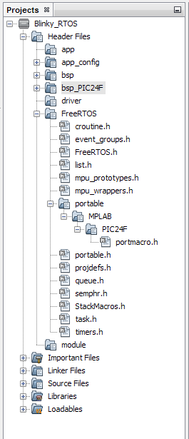Header Files
  + [app]
  + [app_config]
  + [bsp]
  + [bsp_PIC24F]
  + [FreeRTOS]
    - croutine.h
    - event_groups.h
    - FreeRTOS.h
    - FreeRTOSConfig.h
    - list.h
    - mpu_prototypes.h
    - mpu_wrappers.h
    - [portable]
      * [MPLAB]
        + [PIC24F]

portmacro.h

* + - portable.h
    - projdefs.h
    - queue.h
    - semphr.h
    - StackMacros.h
    - task.h
    - timers.h
  + [module/component]
  + [MCC Generated Files]
  + [Utility]
  + version.h
  + Important Files
  + Makefile
  + (.mc3 file)
  + Linker Files
  + 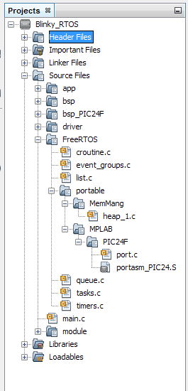Source Files
  + [app]
  + [bsp]
  + [bsp_PIC24F]
  + [FreeRTOS]
    - croutine.c
    - event_groups.c
    - list.c
    - [portable]
      * [MemMang]
        + heap_1.c
      * [MPLAB]
        + [PIC24F]

port.c

portasm_PIC24.S

* + - queue.c
    - tasks.c
    - timers.c
  + main.c
  + [module/component]
  + [MCC Generated Files]
  + [Utility]

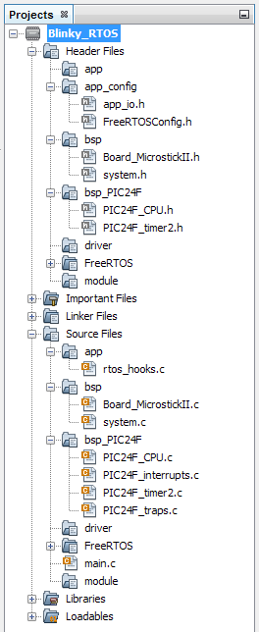Other application files